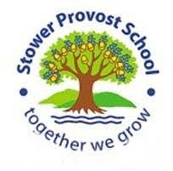

English – we will be looking at writing - looking at using complex, simple and compound sentences as well as learning how to add tension, dialogue and interest in our writing to engage the reader. We will continue with *Kick* by Mich Johnson (with an emphasis on persuasive writing) and *The Journey* by Francesca Sann as well as *Percy Jackson and the Lightning Thief* by Rick Riordan. We will also continue to look at spelling using the Read Write Inc programme and grammar through discrete lessons as we approach our SATs in Year 6. We will also, of course, use the content domains for reading to ask questions and create answers in guided reading and comprehension and examining passages from *Percy Jackson*.

Reading skills will include inference, deduction and fact finding as these are a major importance in effective comprehension.

**Oak Class Summer Curriculum 2024**

**2024**

Oracy – in all subjects, children will be encouraged to speak with clarity and precision and giving evidence and justification for their views.

Maths - looking at calculation as well as reasoning in areas such as ratio and measurement, which are a large part of the maths curriculum. We will also look at algebra. The children will be encouraged to gain fluency in times tables and using known facts to make mathematical links.

inferences. They will also be encouraged to speed up and improve their arithmetic.



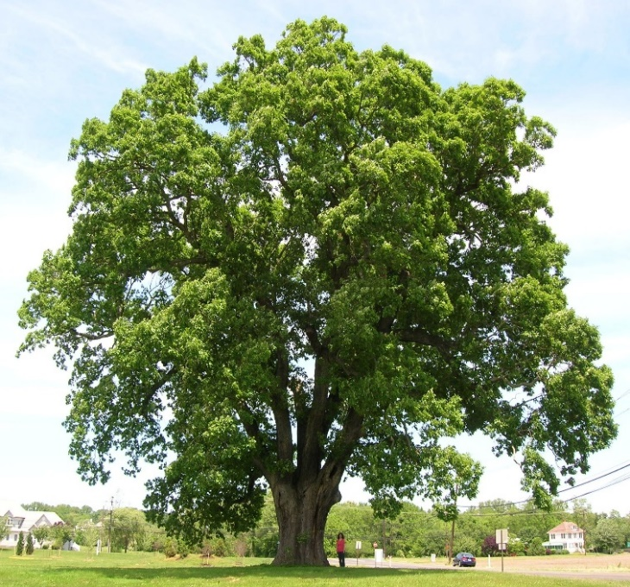

History - This project teaches children about developments and changes over six periods of ancient Greek history, focusing on the city state of Athens in the Classical age, and exploring the lasting legacy of ancient Greece.

PSHE – Relationships and Changing Me – The children will tell explore different types of friendship and ways these might change. They will revise rules about how to stay safe when using technology to communicate with friends. They will revise feelings and changes that happen to girls’ and boys’ bodies during puberty and some of the emotional changes that happen too.

RE-Sikhism and Pentecostal Christianity: Guru Arjan achieved many things during his lifetime. He completed the Golden Temple in Amritsar in 1604 and promoted the Sikh principle of dasvandh. For Christians, Pentecost is celebrated 50 days after Easter. The Bible says Jesus had ascended into heaven and the disciples were waiting to spread Jesus' message. Pentecost is seen as the birthday of the Christian church.

In PE we will be learning about team games both indoors and outdoors. Indoors, we will learn small group games like endball, steal the treasure and beanbag raid, identifying key patterns of play. Outdoors, we will learn to play team games like rounders and cricket. We will move on to swimming sessions later in the term.

Geography - This project teaches children about the features and characteristics of land use in agricultural regions across the world, including a detailed exploration of significant environmental areas.

Science – Our Properties and Changes in Materials project teaches children about the wider properties of materials and their uses. They learn about mixtures and how they can be separated using sieving, filtration and evaporation. They study reversible and irreversible changes and use common indicators to identify irreversible changes.

DT – Our project teaches children about the genre of land art. They work outdoors to sketch natural forms and explore the sculptural potential of natural materials before working collaboratively to create land art installations as well as a project which teaches children about how architectural style and technology has developed over time and then use this knowledge to design a building with specific features.

In Art, our project teaches children about paper crafts, papermaking and collage techniques, including paper, fabric, mixed media and photo collage. They use their learning to create a final piece of small-scale, mixed media collage.

Computing –In computing we will be learning to create vector drawings using different drawing tools to help create images. We create vector drawings using shapes and lines to create objects and we will layer, group and duplicate objects to create more complex pieces of work.

Music- we will be learning to sing, perform with instruments and critique ‘Dancin’ In the Street’ performed by Martha and The Vandellas.We will look at the dynamics and tempo and compare it to other Motown songs too.

PE

French. In this unit we will learn ten phrases to explain the activities we take part in at the weekends. We will also learn how to tell the time in French and using these to support our discussions about weekend activities.